1xx - Controls | 2xx - Ground | 3xx - Flight | 4xx - A2A | 5xx - A2G | 6xx - Misc
300 - Flight - Aircraft Info, Performance Limits

Aircraft Info
- Fuel:
  - Internal: 736 lbs
- Empty weight: 4,184 lbs
- Fully fueled: 4,921 lbs
- Max gross weight: ~5225 lbs
- Tested max speeds (sea level, ISA):
  - Empty: xxx kts
  - MG + Rockets: xxx kts
  - Rockets + Rockets: xxx kts
  - Rockets + Hellfires: xxx kts
  - Hellfires + Hellfires: xxx kts
  - ATAS + ATAS: xxx kts
- Max achievable speed: xxx kts
- Max range cruise: 98 KIAS at sea level, 77-90% torque, slower and less torque as you get higher

Performance limits
- Speeds:
  - Vne forward flight: 110 kts with no doors, 120 kts if > 4,500 lbs or armed, 125 kts otherwise
  - Vne sideways and rearwards: 35 kts
  - Rapid full-left pedal inputs at speeds over 90 kts may cause tail rotor to hit boom.
- NR limits (rotor RPM):
  - Transient: 107-125%, 5 sec
  - Max: 107%
  - Normal: 100%
- NP limits (power turbine):
  - Transient, 5 sec: 107-119%
  - Max: 107%
  - Normal: 100%
- TGT limits (turbine gas temperature):
  - Max, 12 sec: 802-905 °C
  - Max, 30 minute: 716-802 °C
  - Max, continuous: 716 °C
- Torque limits:
  - Transient, 10 sec: 100-116% (no more than 10 seconds cumulative per flight hour)
  - Normal: 100%

Max OGE hover height and weight, 30 minute operation
- Max weight at given altitude: Start at FAT, move across to altitude, move down to see max weight.
- Max altitude at given weight: Start at weight, move up to FAT, read max altitude at intersection.
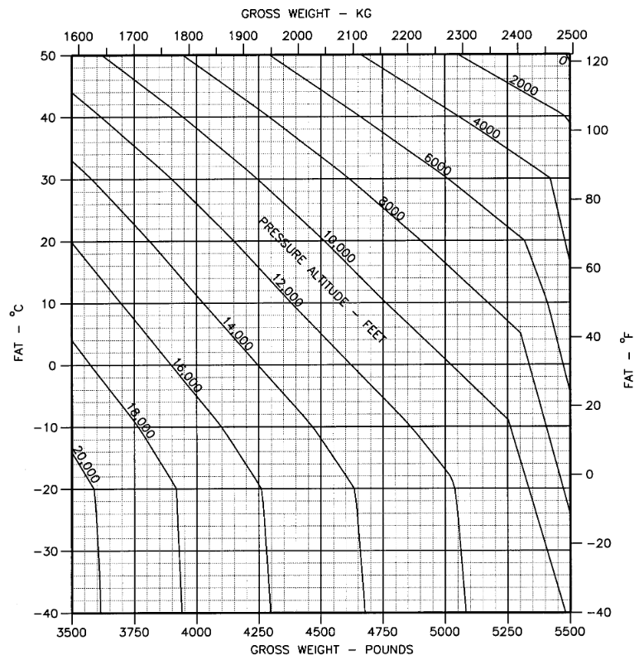
* Note: There are charts in the -10 manual for two engine types; ours is the R variant with the Allison 250-C30/R3.

